# NEW Patient REGISTRATION FORM

|  |  |  |  |  |  |  |  |  |  |  |  |  |  |  |  |  |  |  |  |  |  |  |  |  |  |  |  |  |  |  |  |  |  |  |  |  |  |  |  |  |
| --- | --- | --- | --- | --- | --- | --- | --- | --- | --- | --- | --- | --- | --- | --- | --- | --- | --- | --- | --- | --- | --- | --- | --- | --- | --- | --- | --- | --- | --- | --- | --- | --- | --- | --- | --- | --- | --- | --- | --- | --- |
| (Please Print) | | | | | | | | | | | | | | | | | | | | | | | | | | | | | | | | | | | | | | | | |
| Today’s date: | | | | | | | | | | | | | | | | | | | | | | | | | | Date of Birth: | | | | | | | | | | | | | | |
| PATIENT INFORMATION | | | | | | | | | | | | | | | | | | | | | | | | | | | | | | | | | | | | | | | | |
| Patient’s Last Name: | | | | | | | | | | | First: | | | | | | | | | Middle: | | | | | Age | | | Sex:  M F | | | | | Marital status (circle one) | | | | | | | |
|  | | | | | | | | | | | | | | | | | | | | | | | | | Single / Mar / Div / Sep / Wid | | | | | | | |
| Email: | | | | | | | | | | | | | | | | | | | | | Social Security (Medicare pts only): | | | | | | | | | | | | Cell Phone: | | | | | | | |
|  | | | | | | | | | | | | | | | | | | | | |  | | | | | | | | | | | | ( ) | | | | | | | |
| Street Address: | | | | | | | | | | | | | | | | | | | | | Work Phone:  ( ) | | | | | | | | | | | | Home Phone:  ( ) | | | | | | | |
| P.O. Box: | | | | | City: | | | | | | | | | | | | | | | | | | | | | | State: | | | | | | | | ZIP Code: | | | | | |
|  | | | | |  | | | | | | | | | | | | | | | | | | | | | |  | | | | | | | |  | | | | | |
| Occupation: | | | | | Employer: | | | | | | | | | | | | | | | | | | | | | | | | | | | Employer phone: | | | | | | | | |
|  | | | | |  | | | | | | | | | | | | | | | | | | | | | | | | | | | ( ) | | | | | | | | |
| How did you hear about us? | | | | | | | | | | | | | | | | | | | ❑Dr. | | | ­­­­­­­ | | | | | | | | | | | | Location: | | | | | | ­­­­­­­ |
| ❑ Family | ❑ Friend | | ❑ Close to home/work | | | | | | | | | | | | | ❑ Previous Patient | | | | | | | | | | | ❑ Google | | | ❑ Insurance Plan | | | | | | | | | | |
| EMERGENCY CONTACT | | | | | |  | | | | | | | | | | | | | | | | | | | | | | | | | | | | | | | | | | |
| Name: | | | | | | Relationship and contact info: | | | | | | | | | | | | | | | | | | | | | | | | | | | | | | | | | | |
|  | | | | | | | | | | | | | | | | | | | | | | | | | | | | | | | | | | | | | | | | |
| INSURANCE INFORMATION | | | | | | | | | | | | | | | | | | | | | | | | | | | | | | | | | | | | | | | | |
| (Please give your insurance card to the receptionist.) | | | | | | | | | | | | | | | | | | | | | | | | | | | | | | | | | | | | | | | | |
| Is this patient covered by insurance? | | | | | | | ❑ Yes | | | | | | ❑ No | | |  | | | | | | | | | | | | | | | | | | | | | | | | |
| Please indicate primary insurance | | | | ❑ Aetna | | | | | | | | | | | ❑ BCBSNC | | | | | | | | ❑ BCBS Federal | | | | | | | | ❑ CIGNA | | | | | | | ❑ Coventry | | |
| ❑ Humana | | ❑ Medicare | | | | | | | | ❑ Wellpath | | | | | | | | ❑ United Health Care | | | | | | | | | | | | | ❑ Other | | | | |  | | | | |
| Subscriber’s name: | | | | Policy no.: | | | | | | | | | | | | | Group no.: | | | | | | | Birth date: | | | | | | | |  | | | | | | |  | |
|  | | | |  | | | | | | | | | | | | |  | | | | | | | / / | | | | | | | |  | | | | | | |  | |
| Patient’s relationship to subscriber: | | | | | | | | ❑ Self | | | | | | ❑ Spouse | | | | | ❑ Child | | | | | ❑ Other | | | | |  | | | | | | | | | | | |
| Name of secondary insurance (if applicable): | | | | | | | | | | | | Subscriber’s name: | | | | | | | | | | | | | | | | | Group no.: | | | | | | | | Policy no.: | | | |
|  | | | | | | | | | | | |  | | | | | | | | | | | | | | | | |  | | | | | | | |  | | | |
| Patient’s relationship to subscriber: | | | | | | | | | ❑ Self | | | | | ❑ Spouse | | | | | ❑ Child | | | | | ❑ Other | | | | |  | | | | | | | | | | | |

**CANCELED APPOINTMENT POLICY**

NC Center for Physical Therapy is committed to the care that you need in order to achieve maximum results. You need to attend your appointments.

To allow us to provide better service to you and minimize your wait times we reserve your appointment time specifically for you.

If you need to change or cancel your appointment, we require you to ***notify us*** ***PRIOR to 2:00 the BUSINESS day BEFORE*** your appointment.

If appropriate notice is not given a ***$50 CANCELLATION* FEE** may be imposed.

**DISCHARGE/DISCONTINUATION POLICY**

Please be aware that more than 2 consecutive no shows will result in discontinuation of therapy services.

In order to resume therapy services after discontinuation, a new evaluation/re-evaluation will be required.

**AUTHORIZATION TO PAY PROVIDER AND ASSIGNMENT OF BENEFITS**

The above information is true to the best of my knowledge. I authorize my insurance benefits be paid directly to NC Center for Physical Therapy.

I understand that I am financially responsible for any balance. I also authorize NC Center for Physical Therapy or insurance company to release any information required to process my claims.

**Signature of Patient (or Guardian):_________________________________________________Date:_______________________­­­­­­­­­­­­­**

|  |  |  |  |  |  |  |  |  |
| --- | --- | --- | --- | --- | --- | --- | --- | --- |
| HEALTH HISTORY QUESTIONNAIRE | | | | | | | | |
| All questions contained in this questionnaire are strictly confidential  and will become part of your medical record. | | | | | | | | |
| primary care physician: | | |  | | MOST RECENT APPOINTMENT DATE: | | |  |
| REFERRING PHYSICIAN: | | |  | | MOST RECENT APPOINTMENT DATE: | | |  |
|  | | | | | | | | |
| PERSONAL HEALTH HISTORY | | | | | | | | |
|  | | | | | | | | |
| **Height:** | | **Weight:** | |  |  | |  | |
| Surgeries / HOSPITALIZATIONS | | | | | | | | |
| Year | Reason | | | | | Hospital | | |
|  |  | | | | |  | | |
|  |  | | | | |  | | |
|  |  | | | | |  | | |
|  |  | | | | |  | | |
|  | | | | | | | | |
| Check if you have, or have had, any symptoms in the following areas to a significant degree and briefly explain. | | | | | | | | |

|  |  |  |  |
| --- | --- | --- | --- |
| 🞎 Allergies | 🞎 Currently Pregnant | 🞎 High Cholesterol | 🞎 Rheumatoid Arthritis |
| 🞎 Anemia | 🞎 Depression | 🞎 High/ Low Blood Pressure | 🞎 Seizures |
| 🞎 Anxiety | 🞎 Diabetes | 🞎 HIV/AIDS | 🞎 Smoking |
| 🞎 Arthritis | 🞎 Dizzy Spells | 🞎 Incontinence | 🞎 Speech Problems |
| 🞎 Asthma | 🞎 Emphysema/ Bronchitis | 🞎 Kidney Problems | 🞎 Strokes |
| 🞎 Autoimmune Disorder | 🞎 Fibromyalgia | 🞎 Metal Implants | 🞎 Thyroid Disease |
| 🞎 Cancer | 🞎 Fractures | 🞎 MRSA | 🞎 Tuberculosis |
| 🞎 Cardiac Conditions | 🞎 Gallbladder Problems | 🞎 Multiple Sclerosis | 🞎 Vision Problems |
| 🞎 Cardiac Pacemaker | 🞎 Headaches | 🞎 Muscular Disease | 🞎 Other : |
| 🞎 Chemical Dependency | 🞎 Hearing Impairment | 🞎 Osteoporosis | 🞎 Other : |
| 🞎 Circulation Problems | 🞎 Hepatitis | 🞎 Parkinsons |  |

**Since the onset of your current symptoms, have you had:**

**Y / N Fever/Chills Y / N Malaise (Unexplained tiredness) Y / N Night pain/ sweats**

**Y / N Unexplained weight change Y / N Unexplained muscle weakness Y / N Numbness/ Tingling**

**Y / N Dizziness or fainting Y / N Change in bowel or bladder functions**

**Y / N Other / describe: _________________________________________________________**

**Fall History Urinary Distress History**

|  |  |
| --- | --- |
| 🞎 Injury as a result of a fall in the past year?  🞎 Two or more falls in the past year? | 🞎 Do you experience difficulty emptying your bladder?  🞎 Do you experience small amount of urine leakage (drops)?  🞎 Do you experience urine leakage related to coughing, sneezing or laughing?  🞎 Do you experience urine leakage along with a feeling of urgency, this is a strong sensation  of needing to go to the bathroom? |

|  |  |  |
| --- | --- | --- |
| List your prescribed drugs and over-the-counter drugs,INCLUDING vitamins and inhalers | | |
| Name the Drug | Strength | Frequency Taken |
|  |  |  |
|  |  |  |
|  |  |  |
|  |  |  |

*You can add an additional sheet, if further room is needed.

**Current Complaint/Pain Questionnaire**

**What brings you to physical therapy today?** _______________________________________________________________________

_____________________________________________________________________________________________________________

_____________________________________________________________________________________________________________

**Date of current injury/onset of pain:** _____ /_____ /_____ **Date of surgery:** _____ /_____ /_____

Please use the following symbols to indicate where your pain is and what kind of pain you are having on the diagram to the right.

|  |
| --- |
| Aching: x x x x x |
| Burning: O O O O O |
| Dull: / / / / / / / / |
| Numbness: +++++++ |
| Sharp: ********* |
| Stabbing: > > > > > > > |
| Tingling:# # # # # # # # |
| Throbbing:< < < < < < < |

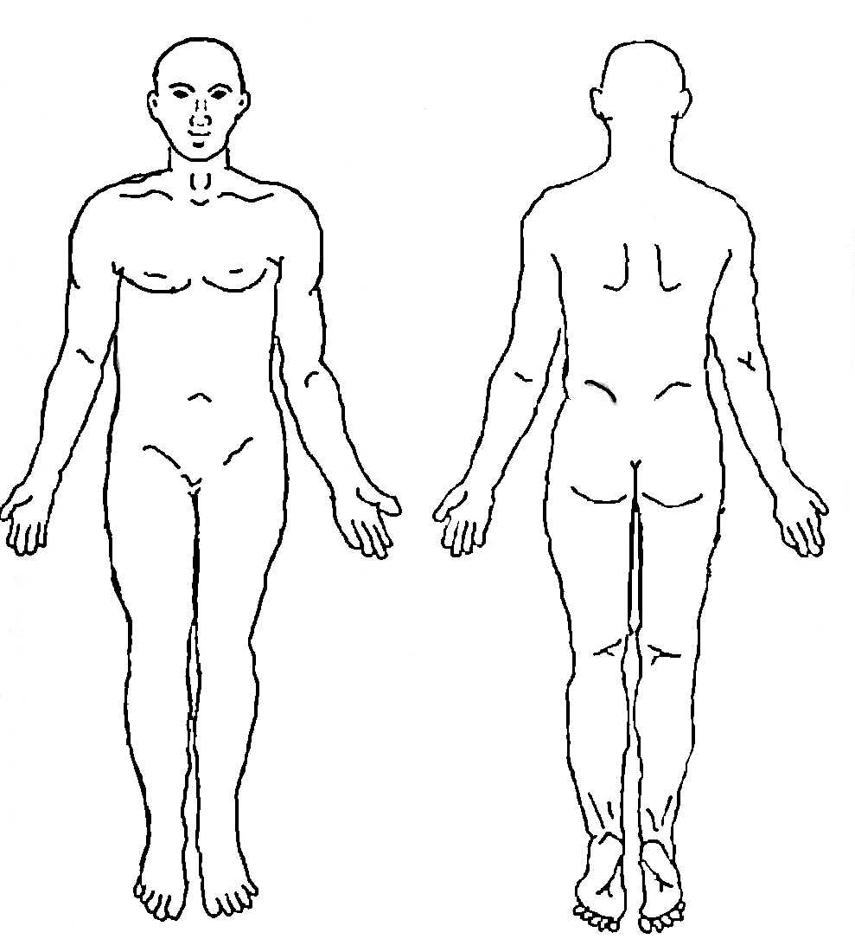

What increases your pain? -

___________________________________

_____________________________________________

What decreases your pain? ­­­­­­­­­­­­­­­­­­­­­­­­­­­___________________________________

_________________________________________________________

Please let us know how severe your pain is. 0 being no pain at all while 10 is the worst pain you can imagine (in other words you would like us to call an ambulance so your pain can be medically controlled)

Please rate your pain **AT THIS MOMENT**



Please rate the **LEAST** amount of pain you have had **IN THE PAST 24 HOURS**



Please rate the **MOST** amount of pain you have had **IN THE PAST 24 HOURS**



**Acknowledgement of Receipt of Privacy Practices**

Please Check One:

🞎 A copy of the Notice of Privacy Practices from NC Center for Physical Therapy is available upon request.

🞎 I have been offered a copy of the Notice of Privacy Practices from NC Center for Physical Therapy, but I have chosen to decline a copy at this time.

Privacy:

In addition to those described in the Privacy Policy, I give my permission for NC Center for Physical Therapy to discuss my health care and billing information with the following people listed below.

Name:___________________________________________________Relationship_________________________

Name:___________________________________________________Relationship_________________________

Name:___________________________________________________Relationship_________________________

If you choose not to have NC Center for Physical Therapy discuss your information with another individual, please check the box below.

* I am the only person besides those described in the Privacy Policy for which my healthcare and billing information should be discussed.

Check ALL boxes Below that Apply:

* EMAIL:

I hereby give permission for NC Center for Physical Therapy to send me email messages regarding appointments. I also authorize emails regarding upcoming clinic events and patient educational newsletters. We will not sell or distribute your email address to any other entity.

🞎 PUBLICATION/WEBSITE PICTURE:

I hereby give permission for NC Center for Physical Therapy to publish photos of me in various forms of publications, or on the website. I give NC Center for Physical Therapy the perpetual, royalty-free right to use my photo(s) in any manner including but not limited to publications and websites. I understand that both the various publications and websites have a large audience and my photo will be available to the general public. I further understand that NC Center for Physical Therapy assumes no liability or responsibility whatsoever concerning any consequences of such use. I understand that if I give notice to the Publications Director or to the webmaster that I object to any particular picture on the website, it will be removed as soon as possible. Publication of these photos may include first names for identification purposes unless I check the box below that I do not give permission for my name to be used.

______ Please DO NOT include my first name with my photo

* TEXTMESSAGES:

I herby give permission for NC Center for Physical Therapy to send text messages regarding appointments. NC Center for Physical Therapy will not be responsible for any incurred text message charges.

🞎 VOICEMAIL:

I hereby give permission for NC Center for Physical Therapy to leave a detailed message on my voicemail/answering machine.

_­___________________________________________ ___________________________________________

Signature of Patient or Responsible Party Date

___________________________________________________ ___________________________________________________

Printed Name of Patient or Responsible Party Date

Financial Policy

Thank you for choosing NC Center for Physical Therapy!

We are committed to your entire experience here being successful! You have a financial responsibility that obligates you to ensure full payment of your bill. All patients must complete and sign the entire patient registration packet before they see the physical therapist. NC Center for Physical Therapy has designed this financial policy to prevent any surprises at the end of the patient’s care. Please read it, ask us any questions you may have, and sign in the space provided. A copy will be provided to you upon request.

**Co-Pays/Co-Insurance/Deductibles:** It is our policy to collect co-pays at the time of service. Co-insurances and deductibles will be paid at an estimated fee based on our contract with each individual insurance company, to be paid at time of visit. Once the claim has been submitted and EOP (Explanation of Payment) has been received from the Insurance company will settle up with you. If you have any concerns with payment, please see owner. A payment plan with valid credit card number must be on file prior to visit.

**Doctor Referrals/Prescriptions:** You are responsible for obtaining the appropriate referral from your physician prior to your appointment, if required by your insurance carrier. It is your responsibility to make sure we have a valid and current copy of your referral in the office at the time of your appointment. Prescriptions, whether for drugs or treatment, are valid for 30 days from the date they are written.

**Guarantee of Payment:** Your healthcare insurance policy is a contract between you and your insurance company or employer. If healthcare insurance does NOT cover your medical services, I agree to pay NC Center for Physical Therapy, LLC all charges NOT covered by insurance or health plan. In the event collection action is undertaken, all costs associated with collections, including attorney fees, will be incurred by the client/legal guardian. I am responsible to provide NC Center for Physical Therapy all accurate insurance information and contact information, including supplemental insurance. If claims are denied due to failure to file claims in a timely manner because I have not provided accurate insurance information, I am responsible for all charges. If I have more than one insurance benefit, I am responsible for coordinating with both insurance companies in the event that there are issues.

**Insurance:** Your insurance policy is a contract between you and your insurance company. We are not a party to that contract. We will bill your insurance plan for you, as long as you provide us with the correct and current information. Your contract dictates the services that are covered and the amount of payment for those services. You are ultimately responsible for payment of services provided. As a courtesy we will verify your insurance eligibility and benefits for physical therapy. However, we strongly advise you to contact your insurance company directly to obtain this information since it is ultimately the patient’s responsibility to know and understand their insurance benefits.

**Insurance Coverage Changes:** If your insurance changes, please notify us before your next visit so we can make the appropriate changes to help you receive your maximum visits and obtain referral/authorizations for the visits. It is your responsibility to notify us of ANY insurance changes as they occur (in writing). Otherwise you may be billed at a private rate per treatment visit. See below.

**Medicare:** See additional sheet regarding Medicare, if applicable to your coverage.

**Payment Issues:** If financial problems arise, please contact our billing department as soon as possible. If an account becomes past due, necessary action will be taken, up to and including turning the account over to our attorney or collections service. The undersigned understands that he/she, or his/her agent, is responsible for charges incurred.

**Secondary Insurance:** As a courtesy, we will bill your secondary insurance, but we require all the plan details at the time of service.

**Uninsured Patients/Private Pay Option:** Evaluation Fee: $150 per visit, Treatment Fee: $85 per visit. These rates are due in FULL prior to the patient’s visit before being seen. I understand coding for insurance billing is not provided with this billing structure nor will it be able to be added at any time.

**Worker’s Compensation Claims/Self-Insured Claims:** We require prior authorization for all Worker’s Compensation claims. You are ultimately responsible for payment of services rendered if your claim is denied. It is your responsibility to provide us with all the information necessary to pursue your claims.

Signed:_________________________________________________________________ Date:__________________________